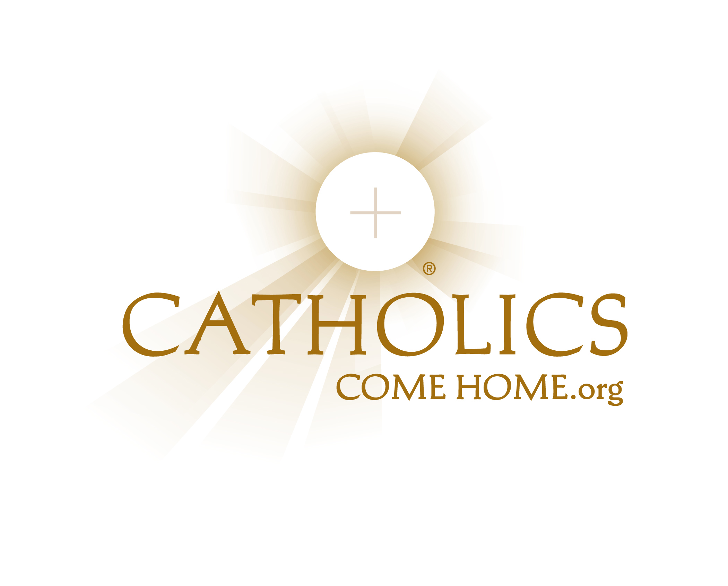

Our recent Catholics Come Home® TV evangelization initiative helped the Roman Catholic Church in (INSERT DIOCESE NAME) share an important and positive message to over (INSERT NUMBER OF PEOPLE REACHED DURING YOUR CAMPAIGN) people in our diocese.

By the time the commercials ended, (INSERT PERCENTAGE INCREASE FOR MASS COUNTS) more Catholics were attending Mass than before. This means that more than (INSERT NUMBER OF PEOPLE INCREASE) Catholics began coming to Mass! Priests also reported noticeable increases in participation in the other sacraments, especially the Sacraments of Baptism and Reconciliation.

The CCH commercials fostered Catholic identity and pride. Parishes reported renewed effects on parish vitality and spirit.

The Positive Impact of
Catholics Come Home®

